Cardinality and Targeted Data  
DAD 220 Intro to Struct Database Environment

Sergio Mateos

Southern New Hampshire University

1. Text

   Description automatically generatedStart terminal.

The command to start would be mysql < mysqlsampledatabase.sql, after that we use the command mysql. After the commands we use USE classicmodels and SHOW TABLES to verify.

1. Retrieve employee tuples and identify the number of employees in San Francisco and New York.

* 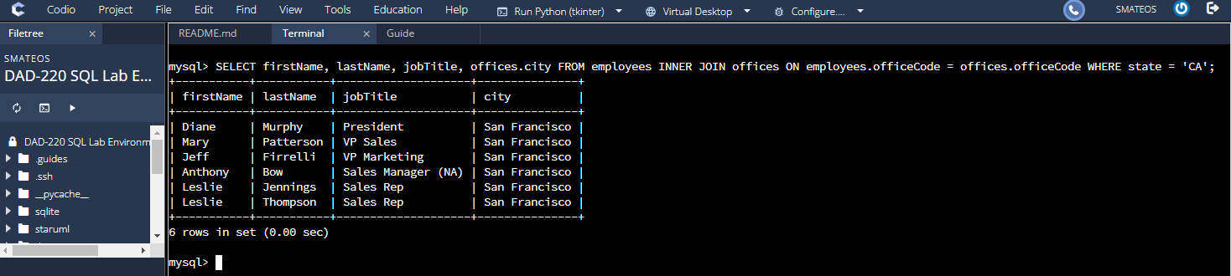California records
* A screenshot of a computer

  Description automatically generatedNew York records

To retrieve the employee in California and New York I used the commands SELECT firstName, lastName, jobTitle, offices.city FROM employees INNER JOIN offices ON employees.officeCode = offices.officeCode WHERE state = 'CA' for California and SELECT firstName, lastName, jobTitle, offices.city FROM employees INNER JOIN offices ON employees.officeCode = offices.officeCode WHERE state = 'NY' for New York.

1. A screenshot of a computer

   Description automatically generated with medium confidenceRetrieve order details for orderNumber 10330, 10338, and 10194 and identify what type of cardinality this represents in the entity relationship model.

To retrieve details for order numbers 10330, 10338, and 10194 we use the command SELECT orders.orderNumber, productCode, quantityOrdered, priceEach, orderlineNumber FROM orders INNER JOIN orderdetails ON orders.orderNumber = orderdetails.orderNumber WHERE orders.orderNumber IN (10330, 10338, 10194) ORDER by orders.orderNumber. These will display the cardinality.

1. Delete records from the payments table where the customer number equals 103.

* 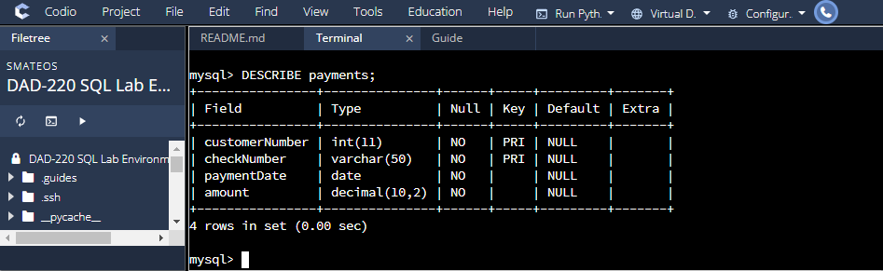DESCRIBE payments.

DESCRIBE payments this display the payments fill that are filled.

* 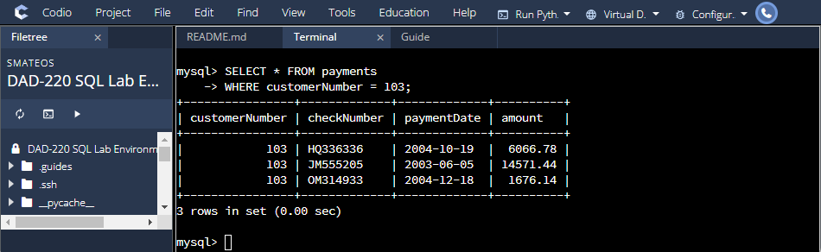Select the record.

SELECT * FROM payments WHERE customerNumber = 103 display list of customer with customerNumber = 103.

* A screenshot of a computer

  Description automatically generatedDelete records.

DELETE FROM payments WHERE customerNumber = 103 delete the record with customerNumber = 103

* A screenshot of a computer

  Description automatically generatedSELECT the table shows customer number 103.

SELECT * FROM payments WHERE customerNumber = 103 will display the new payment table, which is empty to verify that customerNumber = 103 is deleted

1. 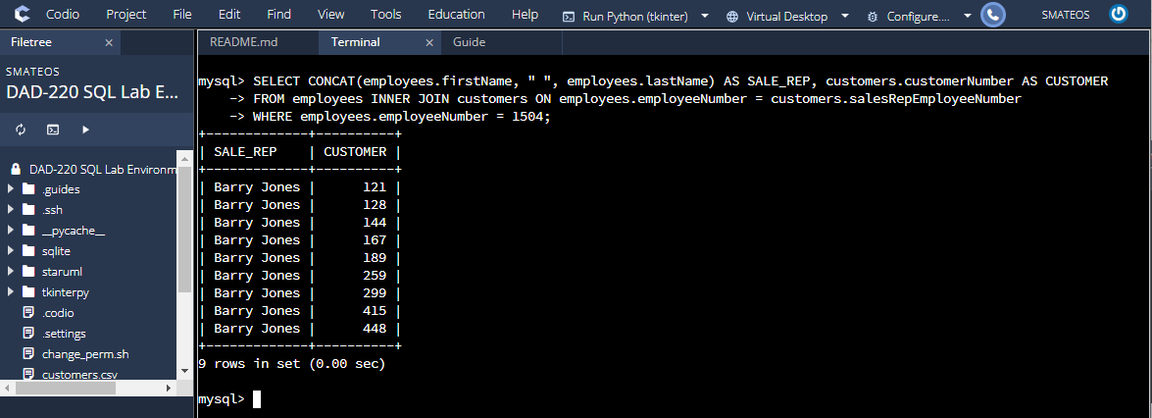Retrieve customer records for sales representative Barry Jones and identify if the relationships are one-to-one or one-to-many.

The command used is SELECT CONCAT(employees.firstName, " ", employees.lastName) AS SALE_REP, customers.customerNumber AS CUSTOMER FROM employees INNER JOIN customers ON employees.employeeNumber = customers.salesRepEmployeeNumber WHERE employees.employeeNumber = 1504. This is one to many relationships. There is a single employee ID with 1504, and there are many Barry Jones as customers.

1. 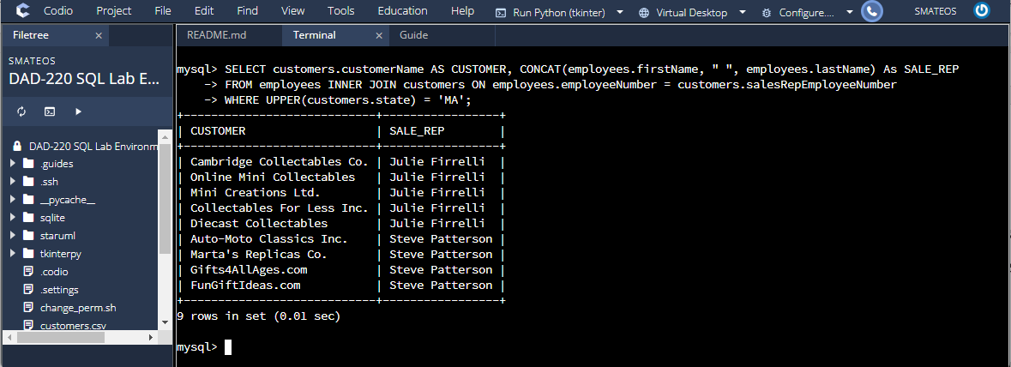Retrieve records for customers who reside in Massachusetts and identify their sales rep and the relationship of entities. Identify if these entities demonstrate one-to-one or many-to-many relationships.

The command SELECT customers.customerName AS CUSTOMER, CONCAT(employees.firstName, " ", employees.lastName) As SALE_REP FROM employees INNER JOIN customers ON employees.employeeNumber = customers.salesRepEmployeeNumber WHERE UPPER(customers.state) = 'MA' display the table. This is a many to one relationship which shows that there are many customers in Massachusetts and each oina has one sales rep.

1. 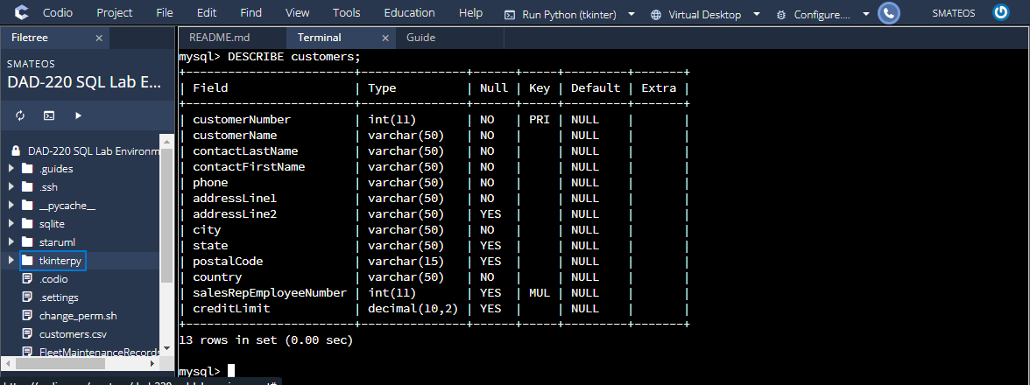A screenshot of a computer

   Description automatically generated with medium confidenceAdd one customer record with your last name using an INSERT statement. You may use the name of a celebrity or fictional character if you don’t use your own name.

Commands to get in the right place.

1. SHOW databases
2. USE classicmodels
3. SHOW TABLES
4. DESCRIBE customers

* A screenshot of a computer

  Description automatically generatedInsert a new customer.

Use command INSERT INTO customers VALUES (1321, 'Umbrella Corp', 'Mateos', 'Sergio', '713-586-3236', '123 Main Ln', '456 Second Main Ln', 'Houston', 'TX', 77043, 'USA', 1612, 1000000.00) to insert a new user using the last name.

* 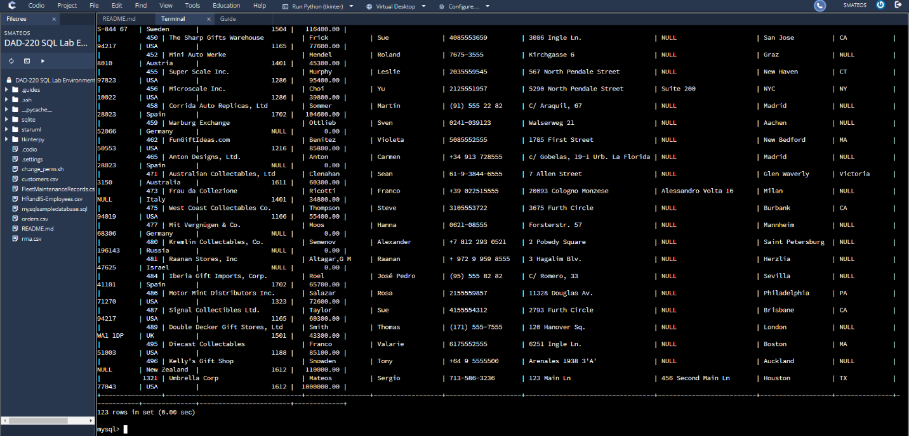SELECT to display table.

1. Reflection.
   1. Cardinality is a mathematical term for the number of elements in each set. The database has a lot of multiple cardinality values across different tables. In our scenario allow the information between different tables on the join conditions. For example, when I retrieve the employee information on California the return was 6 rows, and the New York was 2.
   2. The primary key column in one key was joined with the foreign key column in another table to get the output that will be available to match those records. Some queries were one-to-many, and others were many-to-one.
   3. Two crucial benefits of cardinality are:
      1. Link one tale to another
      2. Check the values if there unique or duplicates.